WEEK 1: DOWLOADING AND KALI LINUX SETUP

Fig 1:Kali Linux running in virtual box
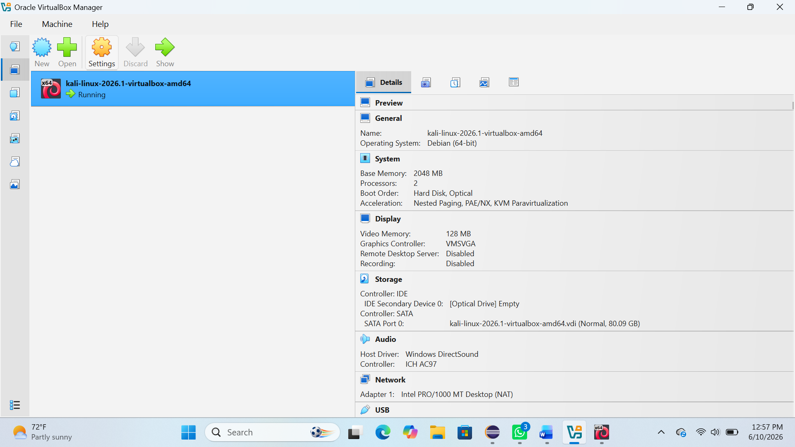

Fig 2:Kali version
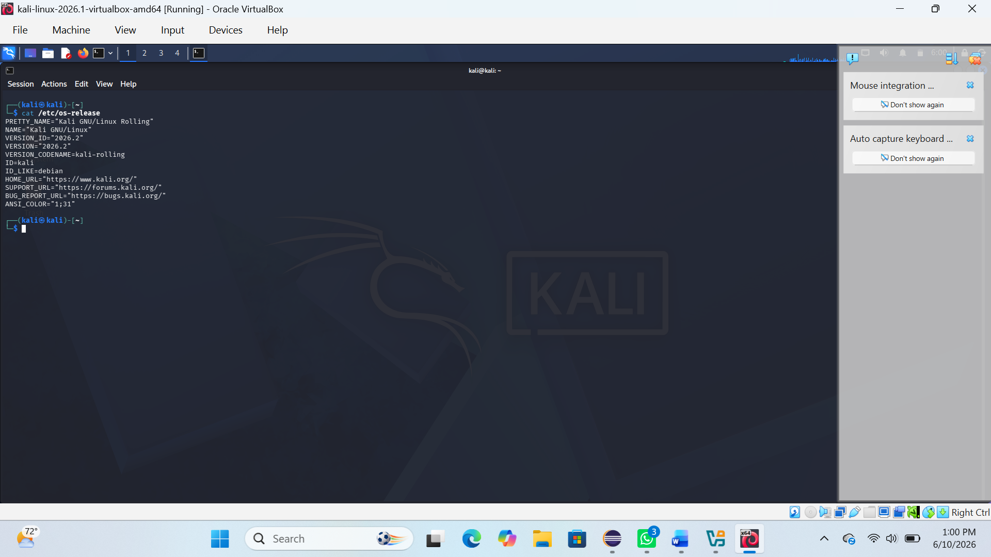

REFLECTION:
I learned how to set up a virtual ethical hacking lab using Kali Linux. I understood the importance of a controlled environment for safe security testing.

